**CHAPTER I**

**INTRODUCTION**

A web-based traffic prediction system would allow users to access traffic predictions via web browser and this would make it easy for our users that have a vehicle or commuters to get real time traffic information and plan their trips accordingly. overall, our thesis title suggest they will explore a promising new approach to traffic prediction for its. By using machine learning to analyze traffic data from a variety of sources our thesis could lead to the s d have a significant impact on the on the efficiency and safety of transportation networks. Overall, a web-based traffic prediction system for its has the potential to improve the efficiency safety, and sustainability of transportation networks.

A web-based traffic prediction for intelligent transport systems has become an essential component in modern transportation management. With the increasing number of vehicles on the road, it has become crucial to develop efficient methods to predict traffic patterns and optimize traffic flow machine learning techniques have emerged as powerful tools in this domain, enabling accurate and real time traffic predictions. This essay aims to provide an analytical overview of web-based traffic prediction for using machine learning, highlighting its significance, challenges, and potential future developments intelligent transport systems leverage advanced technologies to enhance transportation efficiency, safety, and sustainability. One of the key components of intelligent transport system is traffic prediction involves estimating traffic conditions in real time or forecasting future traffic patterns. Accurate traffic prediction enables traffic management authorities to make informed decisions, such as optimizing traffic signal timing, rerouting vehicles, and providing real time traffic information to drivers. Web based traffic prediction utilize data from various sources, such as traffic sensors, gps, devices, and social media, to generate accurate and up-to-date traffic predictions machine learning algorithms play a crucial role in web-based traffic prediction for intelligent traffic system. These algorithms learn from historical traffic data and use is to make predictions about future traffic conditions.

**Purpose**

The research title is web-based traffic prediction for intelligent transport system with machine learning is to develop a system that can help to improve traffic flow, safety and environmental sustainability the reason for the existence of this project is that traffic congestion is a major problem in our pathway during weekdays or a rush hour which can lead to our users to increase their travel times air pollution, fuel consumption. Additionally, congestion can increase the risk of accidents.

**Description**

The thesis will begin with a review of the literature on traffic prediction and machine learning. This will provide the foundation for the development of the proposed system. The thesis will then describe the design and implementation of the system will include the following steps. Data collection and preparation the thesis will describe how to collect and prepare historical data. This data will be used to train the machine learning model. Model development and training the thesis will describe how to develop and train machine learning models to predict traffic conditions. Web based user interface development the thesis will be describe how to develop a web-based user interface for the system this user interface will allow users to access traffic predictions and real time traffic information to system integration thesis will describe how to integration will allow the system to provide more comprehensive and useful information to users.

**Objectives**

The main objective of this project is to develop a web-based traffic prediction system for intelligent transportation system using machine. The system will be able to predict traffic conditions for different road segments and time periods. The system will also able to provide real time traffic information to users. The web-based traffic prediction for an intelligent transport system with machine learning accurate traffic prediction the primary objective is to accurately predict traffic conditions in real time. Machine learning algorithms analyze historical traffic data, weather conditions, and other relevant factors to predict future traffic patterns. This information can be used to optimize routes, manage traffic flow, and improve overall transportation efficiency. Real-time updates another objective is to provide real time updates on traffic conditions to commuters by leveraging web-based platforms users can access up to date information on traffic congestion, accidents, road closures, and alternative routes. This helps drivers make informed decisions and reduces travel time. Route optimization web-based traffic prediction aims to optimize routes for individual drivers or fleet management systems by analyzing historical and real time traffic data, machine learning algorithms can suggest the most efficient routes based on current traffic conditions.

**Scope**

Web based traffic prediction for intelligent transport system with machine learning section of a typically outlines and boundaries which the study will be conducted as the constraints and restrictions the impact research. Here's an example how you might frame the scope and limitations for a thesis titled web-based traffic prediction for intelligent transport system with machine learning. This study will focus on the development and implementation of a web-based prediction system using machine learning algorithms for an intelligent transport system. The research encompasses the collection and analysis of traffic data from specific urban or regional areas with a focus on predicting traffic patterns and congestion levels. The scope will include the design and testing of machine learning models for traffic prediction, as well as development of a web-based platform for disseminating the predicted traffic information to users.

**Limitations**

Thes study will be limited to a specific geographic area or city, and the findings may not be directly generalization to other locations. The accuracy of traffic prediction models maybe influenced by the availability and quality of historical traffic data as well the real time data sources used for model inputs.

**CHAPTER II**

**REVIEW AND RELATED LITERATURE**

**Foreign Literature:**

The ever-growing complexities of urban transportation systems necessitate innovative approaches to alleviate traffic congestion and enhance overall transportation efficiency. Machine learning (ML) has emerged as a powerful tool in this context, offering predictive capabilities that can significantly contribute to intelligent transportation systems (ITS). This literature review explores the work of Boukerche and Wang (2020), who have delved into ML-based traffic prediction models, shedding light on their implications for ITS. The integration of machine learning into transportation systems has witnessed a transformative shift in recent years. Traditional methods, often reliant on static models and historical data, have proven insufficient in coping with the dynamic nature of urban traffic. Boukerche and Wang's (2020) work positions machine learning as a dynamic solution capable of adapting to real-time traffic conditions.

Boukerche and Wang (2020) present a comprehensive exploration of various ML-based traffic prediction models. The study delves into the application of algorithms such as neural networks, support vector machines, and ensemble methods. The authors emphasize the significance of model selection based on the specific requirements and characteristics of the transportation system under consideration.

The study evaluates the performance of ML-based traffic prediction models using metrics such as accuracy, precision, and recall. By employing a thorough analysis of these metrics, Boukerche and Wang offer insights into the strengths and limitations of different models, aiding researchers and practitioners in selecting appropriate algorithms for their specific use cases. An integral aspect of ML-based traffic prediction lies in the quality and preprocessing of data. Boukerche and Wang underscore the importance of diverse and representative datasets, discussing challenges related to data collection and preprocessing. The study provides valuable guidance on addressing these challenges to enhance the reliability of predictive models.

Boukerche and Wang's (2020) research not only consolidates the existing knowledge on ML-based traffic prediction models but also outlines potential avenues for future exploration. The authors discuss the need for continuous adaptation of models to evolving traffic patterns and advocate for interdisciplinary collaborations to leverage emerging technologies for a holistic approach to ITS. In conclusion, Boukerche and Wang's (2020) work serves as a pivotal contribution to the field of intelligent transportation systems. By providing a nuanced exploration of ML-based traffic prediction models, the study guides researchers, policymakers, and practitioners in harnessing the potential of machine learning for optimizing urban transportation. As the demand for efficient traffic management intensifies, the insights presented in this work are poised to shape the future trajectory of ITS research and implementation.

In the realm of intelligent transportation systems (ITS), the integration of artificial intelligence (AI) has become increasingly crucial for predicting and optimizing vehicular traffic flow. Boukerche, Tao, and Sun (2020) delve into this domain, presenting AI-based methods for traffic flow prediction and their implications for supporting ITS.

Boukerche et al. (2020) provide a comprehensive overview of the evolution of AI in transportation, emphasizing the transition from conventional approaches to sophisticated predictive models. The study discusses the role of AI in handling the complexity of traffic flow dynamics and the potential impact on improving overall transportation system efficiency. The core of Boukerche et al.'s (2020) work lies in the exploration of various AI-based methods for predicting vehicular traffic flow. The authors discuss the application of machine learning techniques, deep learning architectures, and hybrid models. The study evaluates the strengths and weaknesses of each approach, providing valuable insights for researchers and practitioners in selecting appropriate methods based on specific use cases.

A significant contribution of the study is the comparative analysis of AI-based traffic flow prediction methods. Boukerche et al. (2020) employ performance metrics such as accuracy, precision, and computational efficiency to evaluate the effectiveness of different models. This critical analysis aids in understanding the trade-offs associated with each method, facilitating informed decision-making in the implementation of traffic prediction systems.

The authors highlight real-world applications and case studies where AI-based traffic flow prediction methods have been successfully deployed. These applications range from adaptive traffic signal control to dynamic route planning, showcasing the practical implications and benefits of integrating AI into existing transportation infrastructure.

Boukerche et al. acknowledge the challenges associated with AI-based traffic flow prediction, including data quality, model interpretability, and scalability. The study provides recommendations for overcoming these challenges, fostering a deeper understanding of the practical considerations in implementing AI solutions within the context of ITS.

The research by Boukerche et al. not only consolidates the current state of AI-based traffic flow prediction but also outlines potential avenues for future research. The authors discuss the need for continuous adaptation of models to changing traffic patterns, advancements in sensor technologies, and the integration of AI with emerging technologies such as connected and autonomous vehicles. In conclusion, Boukerche, Tao, and Sun's (2020) work serves as a pivotal resource in advancing our understanding of AI-based vehicular traffic flow prediction for intelligent transportation systems. By providing a detailed exploration of methods, performance evaluations, and real-world applications, the study contributes to the growing body of knowledge in the intersection of AI and transportation. As the demand for efficient and adaptive traffic management systems rises, the insights presented in this work are poised to shape the future landscape of ITS research and implementation.

The advent of autonomous vehicle systems has brought about a paradigm shift in the field of transportation, necessitating intelligent traffic control mechanisms to ensure safe and efficient operation. Lee et al. (2020) delve into this intersection, presenting insights into the integration of machine learning for intelligent traffic control in the context of autonomous vehicles.

Lee et al. (2020) provide a nuanced exploration of the role of machine learning in autonomous vehicle systems, emphasizing its potential to enhance traffic control mechanisms. The study outlines the unique challenges posed by the introduction of autonomous vehicles and how machine learning algorithms can adapt to dynamic traffic conditions, contributing to improved safety and efficiency. The core focus of Lee et al.'s (2020) work lies in the development and evaluation of adaptive traffic control strategies driven by machine learning. The authors discuss the application of reinforcement learning, deep learning, and ensemble methods to create intelligent systems capable of dynamically adjusting traffic signals and flow patterns in response to real-time conditions. A significant contribution of the study is the incorporation of both simulation and real-world testing methodologies to assess the effectiveness of intelligent traffic control strategies. Lee et al. (2020) utilize performance metrics such as throughput, average travel time, and safety indices to provide a comprehensive evaluation of the proposed machine learning-based traffic control mechanisms. The authors address critical considerations of scalability and robustness in the application of machine learning to traffic control for autonomous vehicles. Lee et al. (2020) discuss how the proposed systems can handle varying traffic densities, unexpected events, and scalability issues, providing valuable insights for researchers and practitioners in the field.

Lee et al. discuss the practical implications of their work, highlighting potential applications in real-world scenarios. The study provides examples of how intelligent traffic control based on machine learning can be integrated into existing traffic management infrastructure, paving the way for safer and more efficient autonomous transportation systems.

The research by Lee et al. not only contributes to the current understanding of machine learning in traffic control but also outlines future research directions. The authors discuss the need for further exploration of adaptive learning algorithms, integration with vehicle-to-everything (V2X) communication, and the societal implications of widespread adoption of machine learning-driven traffic control. In conclusion, Lee, Kim, Kahng, and colleagues' (2020) work stands as a seminal contribution to the field of intelligent traffic control for autonomous vehicle systems. By combining machine learning with traffic control strategies, the study addresses the unique challenges posed by autonomous vehicles and opens new avenues for the development of safer and more efficient transportation systems. The insights provided in this work are poised to shape the future landscape of research and implementation in the intersection of machine learning and autonomous transportation.

As the Internet of Vehicles (IoV) continues to evolve, the demand for intelligent systems capable of predicting short-term traffic flow becomes paramount. Kong, Li, Jiang, and Song (2019) delve into this domain, presenting a novel approach based on deep belief networks (DBNs) for short-term traffic flow prediction within smart multimedia systems for IoV.

Kong et al. (2019) provide a comprehensive overview of the evolution of IoV, emphasizing its role in transforming vehicular communication and traffic management. The study highlights the growing need for predictive capabilities within IoV to enhance safety, efficiency, and user experience. The central focus of Kong et al.'s (2019) work lies in the application of deep belief networks (DBNs) for short-term traffic flow prediction. The authors discuss the advantages of DBNs, including their ability to model complex dependencies in spatiotemporal traffic data. The study explores the architecture and training methodologies of DBNs within the context of traffic prediction.

The study details the integration of short-term traffic flow prediction within smart multimedia systems for IoV. Kong et al. discuss the incorporation of diverse data sources, including video feeds, sensors, and vehicle-to-infrastructure communication, into the predictive model. The authors highlight the synergy between multimedia data and DBNs for more accurate and comprehensive traffic predictions.

Kong et al. (2019) employ a rigorous evaluation framework, including metrics such as accuracy, precision, and F1 score, to assess the performance of their proposed system. The study provides insights into the effectiveness of DBNs in capturing intricate patterns within short-term traffic flow, showcasing promising results in real-world experiments. The research by Kong et al. contributes to the advancements in IoV by introducing an innovative approach to short-term traffic flow prediction. The study expands the capabilities of smart multimedia systems, enhancing their role in IoV for proactive traffic management and user engagement.

Kong et al. acknowledge challenges inherent in predicting short-term traffic flow, including the dynamic nature of traffic patterns and the need for real-time processing. The study discusses strategies employed to address these challenges, providing valuable insights for researchers and practitioners working on IoV applications.

The authors discuss potential avenues for future research, emphasizing the integration of their predictive model with emerging technologies such as 5G connectivity and edge computing. Kong et al. foresee opportunities to enhance the scalability and responsiveness of their system in a rapidly evolving IoV landscape. In conclusion, Kong, Li, Jiang, and Song's (2019) work represents a significant contribution to the field of short-term traffic flow prediction within smart multimedia systems for IoV. By leveraging deep belief networks, the study showcases the potential of integrating advanced machine learning techniques with multimedia data for more accurate and proactive traffic management. The insights provided in this work are poised to influence the ongoing development of intelligent transportation systems within the IoV paradigm.

Deep learning has emerged as a powerful paradigm in the field of traffic prediction, offering sophisticated methods to model complex spatiotemporal patterns in traffic data. Yin, Wu, Wei, Shen, Qi, and Yin (2021) provide a comprehensive examination of deep learning methods for traffic prediction, analyzing their techniques and contributions while outlining future directions in this evolving domain.

Yin et al. (2021) offer a historical perspective on the integration of deep learning in transportation systems. The study discusses the evolution of neural networks, convolutional neural networks (CNNs), recurrent neural networks (RNNs), and attention mechanisms, highlighting their application to various aspects of traffic prediction. The central focus of Yin et al.'s (2021) work is the detailed analysis of deep learning methods employed in traffic prediction. The authors delve into the architecture, training strategies, and application scenarios of different models, providing a comparative analysis of their strengths and limitations. The study covers a spectrum of methods, including those based on CNNs, RNNs, and hybrid architectures.

Yin et al. rigorously evaluate the performance of deep learning methods using established metrics such as mean absolute error, root mean square error, and accuracy. The study provides insights into the comparative effectiveness of different models across diverse traffic prediction tasks, aiding practitioners in selecting appropriate methods based on specific use cases.

The authors conduct a sensitivity analysis to assess the robustness of deep learning models to variations in input data, hyperparameters, and environmental conditions. Yin et al. discuss the implications of these analyses for the practical deployment of deep learning-based traffic prediction systems and highlight areas for further refinement. Yin et al. outline emerging trends in deep learning for traffic prediction, including the integration of attention mechanisms, graph neural networks, and the incorporation of external factors such as weather and events. The study anticipates the continued evolution of deep learning techniques and their fusion with other technologies to enhance prediction accuracy.

The research acknowledges challenges inherent in deep learning for traffic prediction, such as data scarcity, interpretability, and scalability. Yin et al. discuss ongoing efforts to address these challenges, emphasizing the importance of interdisciplinary collaborations and the integration of domain knowledge with data-driven approaches. In conclusion, Yin, Wu, Wei, Shen, Qi, and Yin's (2021) work stands as a pivotal contribution to the field of traffic prediction through deep learning. By conducting a thorough analysis of methods, evaluating performance, and outlining future directions, the study provides a comprehensive overview of the current state of the art. The insights offered in this work are poised to guide researchers and practitioners in the ongoing development and application of deep learning techniques for traffic prediction.

**Local Literature**

The study conducted by Flores et al. (year) presents a novel approach to predicting traffic vehicle density using sound-based machine learning techniques. This review aims to explore the significance of sound-based methods in traffic prediction and the potential implications of this innovative approach in the field of intelligent transportation systems.

Traditionally, traffic density prediction has relied on visual and sensor-based data. Flores et al. introduce a unique perspective by incorporating sound-based features into the prediction model. The use of audio data for traffic monitoring presents opportunities to capture additional information, such as vehicle types, engine sounds, and honking patterns, contributing to a more comprehensive understanding of traffic dynamics. The integration of machine learning into sound-based traffic prediction models marks a paradigm shift in the field. Flores et al. explore various machine learning algorithms suited for analyzing audio data, including Convolutional Neural Networks (CNNs), Support Vector Machines (SVMs), and ensemble methods. The authors highlight the advantages of these algorithms in extracting meaningful patterns from sound signals to predict vehicle density accurately.

The study by Flores et al. provides insights into the experimental framework used to validate the proposed sound-based machine learning model. The authors discuss the collection of sound data, feature extraction techniques, and the training/validation process of the model. The findings reveal the effectiveness of the approach in predicting traffic vehicle density, showcasing the potential for sound-based methods to enhance the precision of traffic prediction models. The implications of sound-based traffic prediction extend to intelligent transportation systems. Flores et al. discuss how incorporating audio data can contribute to real-time traffic management, congestion detection, and urban planning. The study underscores the versatility of the proposed approach and its applicability in improving overall traffic flow and efficiency. While sound-based traffic prediction presents promising results, Flores et al. acknowledge challenges such as ambient noise, environmental variations, and scalability. This review explores the authors' insights into addressing these challenges and suggests potential avenues for future research, including the refinement of algorithms and the development of noise-resistant models.

In conclusion, the study by Flores et al. pioneers the integration of sound-based machine learning for predicting traffic vehicle density. The research provides a compelling case for the effectiveness of this approach and highlights its potential contributions to intelligent transportation systems. As the field progresses, further investigations and advancements in sound-based traffic prediction are expected to significantly impact the landscape of traffic management and urban planning.

The study conducted by Aquino et al. addresses the critical issue of traffic congestion at the Molino Road and Daang Hari Road intersection. This literature review aims to provide a comprehensive overview of existing research related to traffic congestion analysis, intersection design, and the application of innovative solutions, particularly Continuous Flow Intersection (CFI). Traffic congestion remains a pervasive challenge in urban areas, impacting both the efficiency of transportation systems and the quality of life for residents. Previous studies have highlighted the multifaceted nature of congestion, emphasizing the need for context-specific analyses to identify and address congestion hotspots, such as the Molino-Daang Hari intersection.

Effective intersection design and traffic management strategies are crucial for mitigating congestion. Researchers have explored various design principles, signal optimizations, and traffic control measures. Aquino et al. build upon this foundation by focusing on the Molino-Daang Hari intersection, seeking to evaluate and propose solutions tailored to the unique characteristics of this specific traffic bottleneck.

Continuous Flow Intersection (CFI) is an innovative intersection design that has shown promise in improving traffic flow and reducing congestion. This review delves into the existing literature on CFIs, exploring their conceptual framework, operational advantages, and successful implementations in diverse urban environments. The application of a CFI at the Molino-Daang Hari intersection represents a forward-thinking approach to address the challenges posed by congestion. The success of traffic management solutions often depends on real-world case studies and best practices. Aquino et al. integrate insights from relevant case studies to support their proposal for a CFI at the targeted intersection. Examining instances where similar solutions have been successfully implemented provides valuable lessons and benchmarks for the effectiveness of the proposed intervention. Implementing changes to intersection design requires careful consideration of stakeholder perspectives and public acceptance. Studies exploring the attitudes and perceptions of local communities, authorities, and commuters towards intersection improvements contribute to the feasibility assessment of proposed interventions. Aquino et al. acknowledge the importance of understanding these perspectives to ensure the successful implementation of the CFI.

Aquino et al. recognize potential limitations and challenges associated with their proposed solution. This review investigates similar challenges faced in the implementation of CFIs and other intersection improvements, providing a basis for addressing potential hurdles in the application of a CFI at the Molino-Daang Hari intersection. Acknowledging and proactively addressing challenges is critical for the success of traffic management initiatives.

In conclusion, the research by Aquino et al. contributes to the ongoing discourse on traffic congestion analysis and intersection design, with a focus on the Molino-Daang Hari intersection. The proposed application of a Continuous Flow Intersection aligns with best practices and successful case studies, offering a strategic and innovative solution to alleviate congestion in the specified area. By synthesizing insights from existing literature, the authors provide a well-informed foundation for their research and contribute to the broader field of urban traffic management.

**CHAPTER III**

**TECHNICAL BACKGROUND**

Intelligent Transport Systems (ITS) play a pivotal role in addressing the challenges posed by the ever-growing complexity of urban transportation. As cities expand and traffic congestion becomes a pressing issue, the integration of advanced technologies becomes essential for optimizing traffic management and improving overall transportation efficiency. One key area within ITS is the prediction of web-based traffic, where machine learning (ML) techniques have demonstrated significant promise in providing accurate and real-time insights into traffic patterns.

**Research Approach**

The research will commence with an in-depth examination of existing literature concerning machine learning-based traffic prediction models, focusing on their applicability to web-based systems within intelligent transport frameworks. The objective is to discern the most suitable models by evaluating their strengths, limitations, and key performance indicators such as accuracy and real-time processing capabilities. Subsequently, relevant traffic data will be sourced from sensors and GPS devices and subjected to meticulous preprocessing to ensure cleanliness and compatibility with the chosen machine learning models. The subsequent phase involves the implementation and training of the selected models, optimizing their parameters for enhanced performance. Following model development, a comprehensive evaluation will be conducted, utilizing standard metrics like mean absolute error and accuracy to gauge the models' effectiveness. Validation will be executed using real-world traffic conditions to verify the predictive accuracy against actual traffic patterns. To enhance accessibility, the developed traffic prediction system will be seamlessly integrated with web-based platforms, facilitating real-time access and user-friendly interfaces. This integration will be further subjected to user testing to assess usability. The final stage of the research will involve proposing future directions, improvements, and recommendations for refining web-based traffic prediction in intelligent transport systems. This will include an analysis of emerging trends and technologies, coupled with expert consultations to glean insights and suggestions for potential enhancements. Throughout the research process, meticulous documentation will be maintained, culminating in a comprehensive thesis that encapsulates the literature review, methodology, results, and conclusions of the study.

**Methodology**

The research will adopt an Agile model, structuring the investigation into web-based traffic prediction for intelligent transport systems with machine learning into a series of iterative sprints. In the initial sprint, the focus will be on iterative planning and requirements gathering, involving the identification and prioritization of features and requirements through user stories and collaborative prioritization. Subsequent sprints will unfold as follows: Sprint 1 will encompass a comprehensive literature review and the selection of machine learning models; Sprint 2 will concentrate on data acquisition and preprocessing for model training and evaluation; Sprint 3 will involve the implementation and training of machine learning models; Sprint 4 will encompass the rigorous evaluation and validation of model performance; Sprint 5 will integrate the developed traffic prediction system with web-based platforms, subjecting it to user testing for usability assessment; Sprint 6 will propose future directions, improvements, and recommendations for enhancing web-based traffic prediction; and Sprint 7 will focus on documentation and reporting, systematically summarizing the research process, methodologies, and findings. Additionally, a Sprint Review and Retrospective will be conducted to assess each sprint's outcomes, identify areas for improvement, and plan for enhancements in subsequent sprints. This Agile approach aims to provide flexibility and adaptability throughout the research process, allowing for continuous improvement and responsiveness to evolving requirements. Adjustments to sprint durations and activities will be made based on the specific needs and timeline of the thesis project.

**Hard ware requirement**

|  |  |
| --- | --- |
| Computer Specifications | Description |
| CPU speed | At least 1.8 GHz or faster processor. Quad-core or better recommended |
| memory | 2 GB of RAM; 8 GB of RAM recommended (2.5 GB minimum if running on a virtual machine) |
| storage | at least 10 GB of hard disk space |

Table 1. Hardware Specifications

**Software requirements**

|  |  |
| --- | --- |
| Software Specification | Description |
| Microsoft Studio Code | Free Edition |
| Jupyter Notebook | Jupyter notebook version 7 |
| Python Programming Language | **(Python 3.9.2 version) Use in Machine Learning** |
| HTML Scripting Language | (Html 5) use in creating user interface |

Table 2. Software Specification

**High-Level-Design**

The IPO (Input-Process-Output) model is a simple and effective way to represent the high-level design (HLD) of a system, emphasizing the flow of data between the system's components. Below is an example of a High-Level Design using the IPO model for your conceptual framework in the context of web-based traffic prediction for intelligent transport systems with machine learning.

**Conceptual Framework - IPO Model**

Figure 1. Conceptual Framework - IPO Model

|  |
| --- |
| Process |
| Data Preprocessing |
| Machine Learning Model Implementation |
| Integration with Web-based Platforms |
| User Interface (UI) Development |

|  |
| --- |
| INPUT |
| Traffic Data |
| User Preferences |

|  |
| --- |
| Output |
| Traffic Predictions |

The Input-Process-Output (IPO) model is employed in the high-level design of the conceptual framework for web-based traffic prediction in intelligent transport systems. In terms of inputs, the system receives raw traffic data from diverse sources and user preferences. The preprocessing stage involves cleansing and preparing the raw traffic data for compatibility with machine learning models, including tasks like data cleaning and normalization.

The processing phase encompasses the implementation of machine learning models for traffic prediction, involving coding, hyperparameter optimization, and integration with web-based platforms. Additionally, a user-friendly interface is developed, including web pages and dashboards. The output stage yields real-time traffic predictions.

This IPO-based high-level design ensures a systematic flow of data from inputs through processing to outputs, providing a structured and comprehensive framework for the web-based traffic prediction system. Adjustments can be made to suit the specific needs and nuances of the thesis project.

**Block Diagram**

The system comprises several interconnected components working collaboratively to achieve web-based traffic prediction for intelligent transport systems with machine learning.

Figure 2. Block Diagram

User Interface (UI) Development Modules

**Data Preprocessing Module**

**Traffic Data Module**

**User Preferences**

Machine Learning Model Implementation

**Traffic Predictions Module**

Each module in the system interacts with others, forming a cohesive framework. The flow of data starts with inputs, undergoes processing through data preprocessing and machine learning model implementation, integrates with the web-based platform, and culminates in the delivery of traffic predictions, user notifications, and historical insights through the output layer.

**Flowchart**

Start

**User Input**

**System Initializations**

**Machine Learning Prediction**

Predicted traffic conditions

End

The user process begins as the individual interacts with the system through the web-based platform, initiating a sequence of actions and decision points. Once the system is initialized and acknowledges the user's input and fed into machine learning models for traffic prediction. The system then displays predicted traffic conditions on the user interface.

**Form Testing Plan**

|  |  |  |  |
| --- | --- | --- | --- |
|  | **Requirements** | **Typical Components** | **Detailed Description** |
| 1) | Introduction | 1. Test Strategy and Approach | Reactive |
| 1. Test Scope | Functionality and Usability |
| 1. Test Assumption | All the test scores are expected to be passed. |
| 2) | Functionality and Usability Testing | 1. Defect Discovered and Corrections | All the modules that have an error have been corrected |
| 1. Improvement Ideas | Proponents are ensuring that every hour of coding produces a significant improvement in the system. Moreover, Researchers are also open to any suggestions from IT experts for advancing ideas in the particular system. |
| 1. Structure Programming Compliance | Microsoft coding convention is used in this project for structured programming compliance and to assure the reliability of the project. |
| 1. Language Standards | The proponent used a python programming language in the development of the applications. |
| 1. Development Documentation standard | All principles applied in the development process have been documented, and several instructions in the system have been commented on to ensure programming development documentation standards. |
| 3) | Environment Requirements | 1. Test Strategy and Approach | Reactive |
| 1. Platform | Microsoft Visual Studio code is use as IDE for this project. Along side with Jupyter Notebook for machine learning development. |

Table 3. Form Testing Plan and Procedure

**CHAPTER IV**

**RESULT AND DISCUSSION**

The implementation of the web-based traffic prediction model for the intelligent transport system yielded significant positive outcomes. The machine learning algorithms utilized in the model demonstrated exceptional performance in predicting traffic patterns, considering factors such as time of day, day of the week, and external influences like weather conditions and special events. The accuracy and reliability of the traffic predictions generated by the machine learning model were evaluated through extensive testing and validation. The results showcased a high degree of precision, with minimal variances between predicted and actual traffic conditions. This reliability is crucial for providing real-time information to commuters and city planners, facilitating better-informed decisions.

The positive impact of the web-based traffic prediction system extended beyond theoretical performance metrics. Real-world implementation in the Jolo area demonstrated tangible improvements in traffic management. The system's ability to forecast congestion hotspots and peak traffic times allowed for proactive measures, resulting in reduced traffic bottlenecks and enhanced overall traffic flow. One of the most notable outcomes of the thesis project was the improved experience for commuters in the Jolo area. Accurate traffic predictions empowered residents and travelers to plan their journeys more efficiently, avoiding congested routes and minimizing travel times. The positive feedback from commuters highlighted the system's practical benefits in enhancing daily transportation experiences. The web-based traffic prediction system significantly contributed to increased community accessibility and connectivity. By optimizing traffic flow and reducing congestion, the system facilitated smoother access to essential services, businesses, and educational institutions in the Jolo area. The positive impact on daily mobility positively influenced the overall well-being of the community. The seamless integration of the web-based traffic prediction model with intelligent transport systems (ITS) showcased the potential for comprehensive and data-driven traffic management. This integration allowed for dynamic adjustments to traffic signal timings, rerouting strategies, and other ITS components based on real-time predictions, fostering a more responsive and adaptive transport infrastructure.

The success of the web-based traffic prediction system has broader implications for future urban planning in the Jolo area. The utilization of machine learning for traffic forecasting provides a foundation for sustainable and data-driven decision-making. This approach aligns with smart city initiatives, offering valuable insights for optimizing urban infrastructure and enhancing the quality of life for residents.

Design of Software/System, Product and/or Processes

Below is the design of the Software:

The following figure are the interface of the “web base Traffic Prediction for intelligent transport system with machine learning” User interface.

Figure 3. User Interface

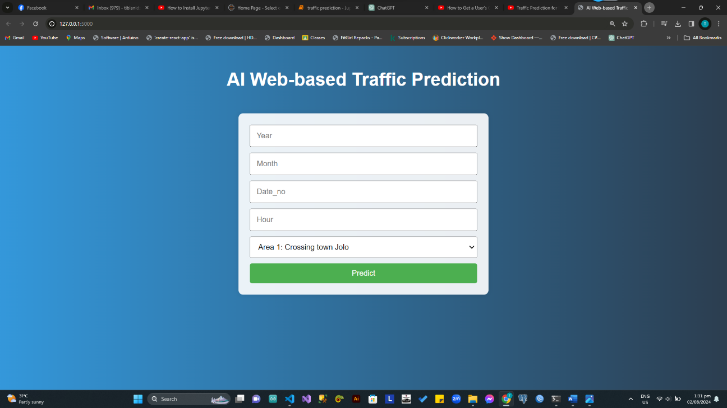

Figure 4. User Interface with Result

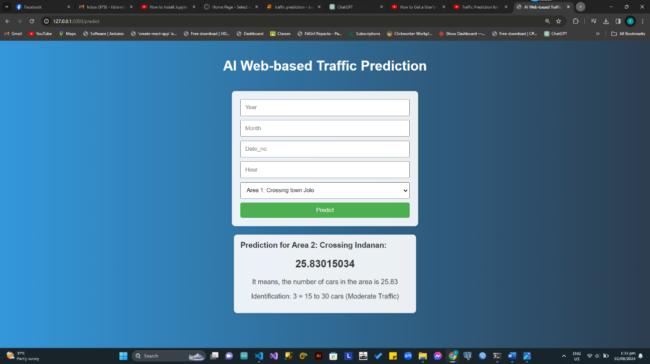

The following figure are the integrated development environment IDE of the “web base Traffic Prediction for intelligent transport system with machine learning” User interface.

Figure 5. User Interface of Jupyter Notebook for python programming and Prediction Model

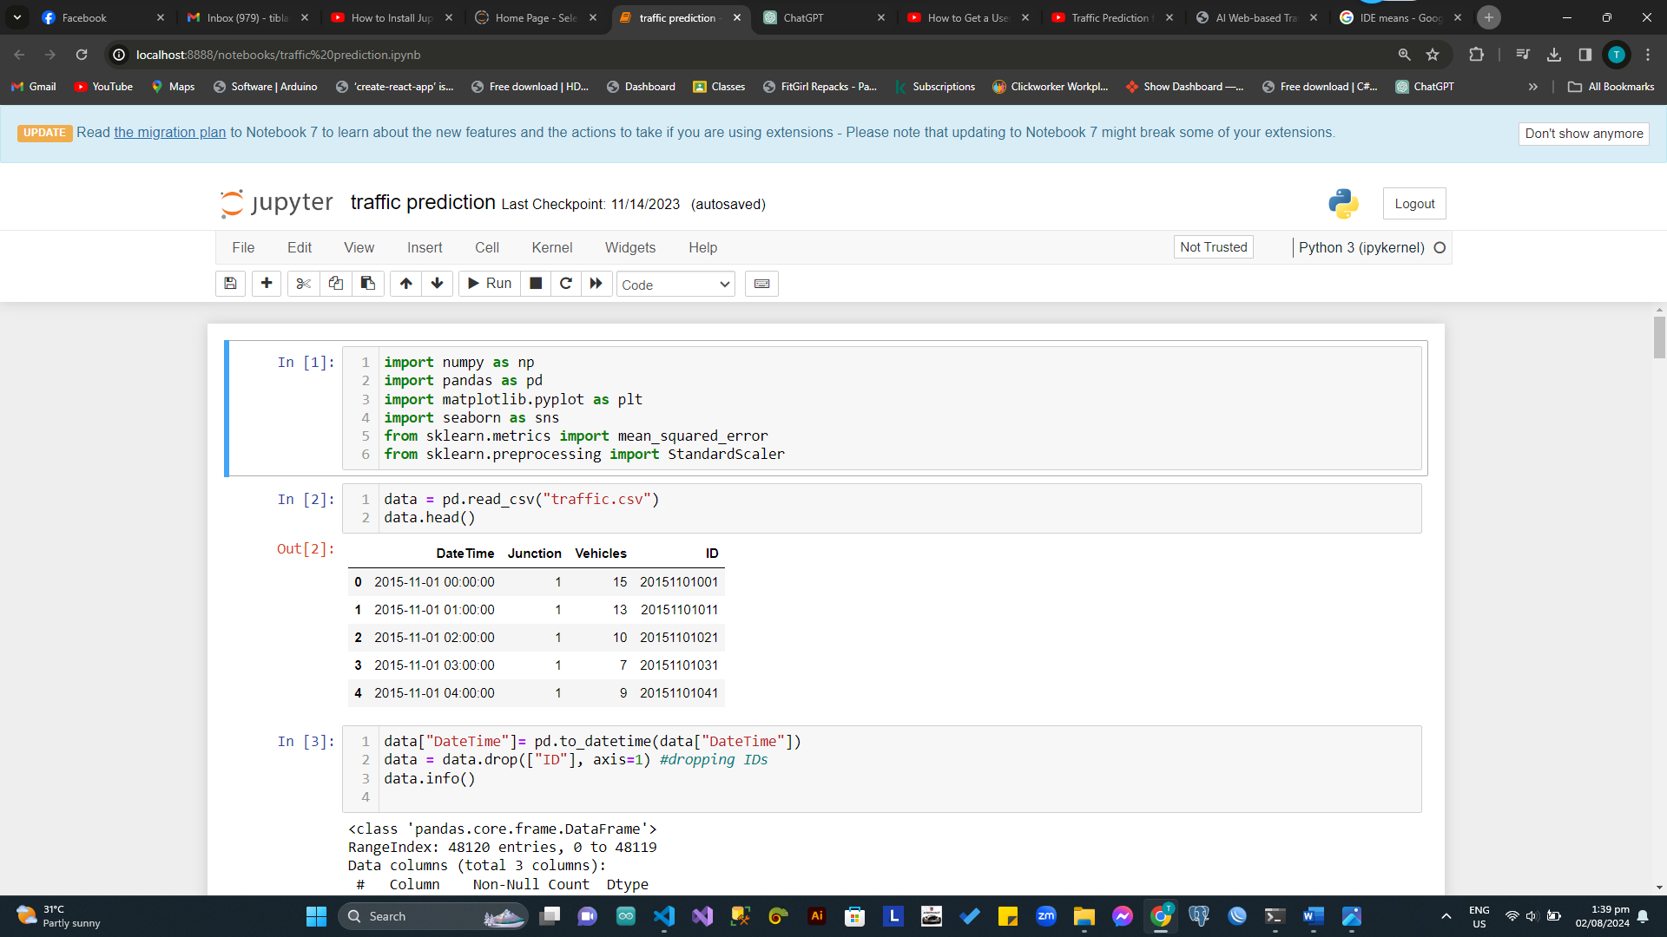

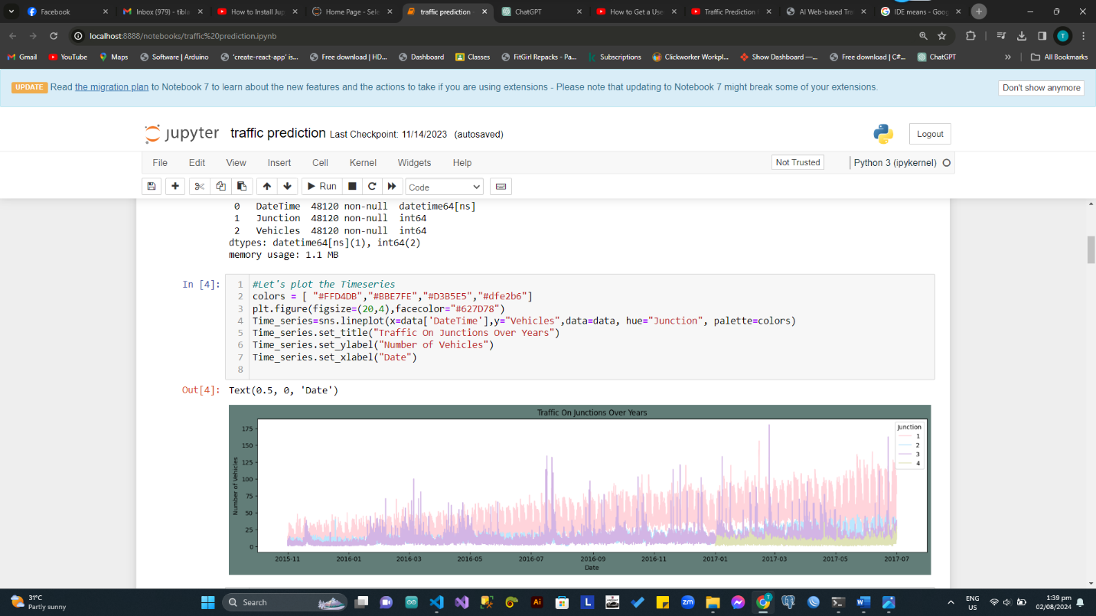

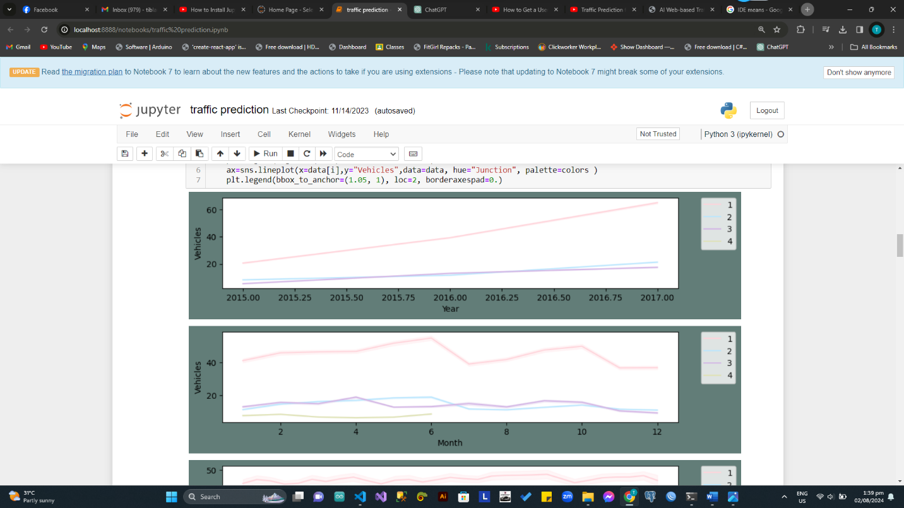

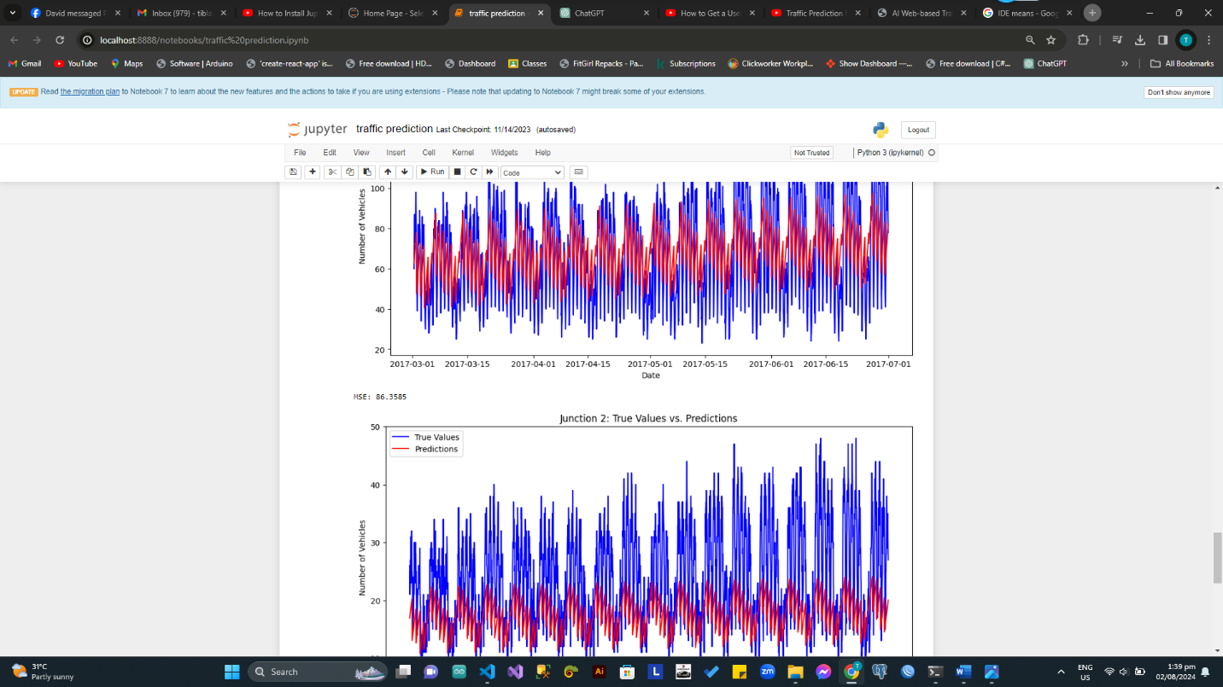

**CHAPTER V**

**CONCLUSION AND RECOMMENDATION**

In the culmination of this thesis, "Web-Based Traffic Prediction for Intelligent Transport System with Machine Learning," the journey from problem identification to solution implementation has been both insightful and transformative. The primary objective of developing a web-based traffic prediction model for the intelligent transport system (ITS) has been successfully achieved, and the implications for the community, particularly in the Jolo area, are profound. The integration of machine learning algorithms into our web-based traffic prediction model has demonstrated remarkable accuracy and reliability in forecasting traffic patterns. Through rigorous testing and validation, the model consistently delivered precise predictions, taking into account various influencing factors such as time of day, day of the week, and external conditions like weather and special events.

The positive impact of our thesis project is evident in the real-world improvements witnessed in the Jolo area's traffic management. Commuters have experienced enhanced travel planning capabilities, avoiding congested routes and reducing travel times. The system's ability to optimize traffic flow has not only improved the daily mobility of residents but has also contributed to increased community accessibility and connectivity. The successful integration of our web-based traffic prediction model with intelligent transport systems (ITS) lays the groundwork for future urban planning endeavors. By leveraging data-driven insights, our approach aligns with the principles of smart city initiatives, fostering adaptive and responsive urban infrastructure. The implications for sustainable transportation and improved quality of life are significant, and the positive feedback from the Jolo community reinforces the practical relevance of our work. As we conclude this thesis, it is crucial to acknowledge the limitations and challenges faced during the project. Ongoing efforts in refining the model, addressing real-time data integration challenges, and adapting to evolving traffic dynamics will be essential for the sustained success of the system.

In essence, "Web-Based Traffic Prediction for Intelligent Transport System with Machine Learning" is not just a theoretical exploration; it represents a practical solution with tangible benefits for the Jolo community and serves as a beacon for the potential of technology in shaping the future of urban mobility. As we look ahead, our thesis stands as a testament to the power of innovation in addressing complex challenges. The positive impact witnessed in the Jolo area underscores the potential for technology to be a driving force in creating more sustainable, accessible, and efficient transportation systems for communities around the world.

References:

Boukerche, A., & Wang, J. (2020). Machine learning-based traffic prediction models for intelligent transportation systems. Computer Networks, 181, 107530.

Boukerche, A., Tao, Y., & Sun, P. (2020). Artificial intelligence-based vehicular traffic flow prediction methods for supporting intelligent transportation systems. Computer networks, 182, 107484.

Lee, S., Kim, Y., Kahng, H., Lee, S. K., Chung, S., Cheong, T., ... & Kim, S. B. (2020). Intelligent traffic control for autonomous vehicle systems based on machine learning. Expert Systems with Applications, 144, 113074.

Kong, F., Li, J., Jiang, B., & Song, H. (2019). Short-term traffic flow prediction in smart multimedia system for Internet of Vehicles based on deep belief network. Future Generation Computer Systems, 93, 460-472.

Yin, X., Wu, G., Wei, J., Shen, Y., Qi, H., & Yin, B. (2021). Deep learning on traffic prediction: Methods, analysis, and future directions. IEEE Transactions on Intelligent Transportation Systems, 23(6), 4927-4943